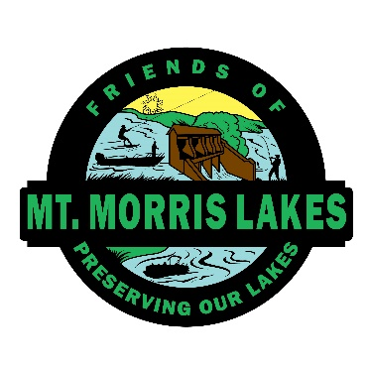

FRIENDS OF MT. MORRIS LAKES ENDOWMENT FUND

The Mount Morris Lakes Management District (MMLMD) is in charge of the important work of maintaining our beautiful lake system. In the past it has relied on assessment funds and available grants to carry out this important task. The future of the grants that have helped us in previous years may not be available to us in the future.

The Friends of Mount Morris Lakes (FOMML) Endowment Fund was established in 2014 to provide an added source of revenue to carry on this important work for generations to come. With support from members of the MMLMD like you, members of the community at large and partners in the business community, we are building an endowment fund that will help ensure that future.

Please consider contributing your gift of any size, to aid in building the endowment. When we get to the point where we can produce meaningful income, we will help defray some of the shared taxes paid by all of us as property owners. Your contribution is **fully deductible**, and we provide substantiation for your tax records.

You may **make your gift online** at [www.oshkoshareacf.org](http://www.oshkoshareacf.org) with a credit card:

*-Click GIVE NOW in the upper right hand corner of the screen.*

*-Then choose CLICK HERE TO DONATE NOW.*

*-Next In the search bar type Mount Morris and our fund will appear (Friends of Mount Morris Lakes Endowment Fund). You can then enter the amount and Add to Cart.*

Or a check can be mailed by printing out the Contribution Form on this website.

Your **tax benefits can be compounded** by taking advantage of some additional ways to give:

-a gift of appreciated securities

-a qualifying charitable distribution (QCD) from an IRA.

-Include FOMML in your estate planning.

If you would like information on these and other donation options simply send an email to [friendmmlake@gmail.com](mailto:friendmmlake@gmail.com), and one of our committee members will get in touch. You can also send an email if you would like to be added to our email distribution list or would like to see a financial report.

Your Friends of Mount Morris Lakes endowment committee

*Kathy Croft , Mary Rohr, June Schroeder, Rick Walters*